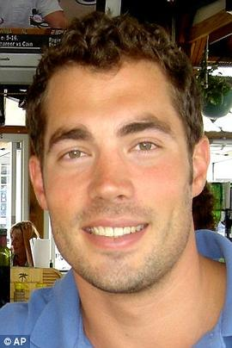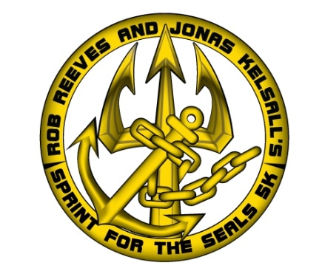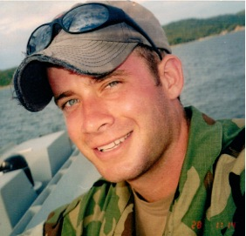
Jonas Kelsall, graduate of University of Texas NROTC, member of SEAL Team Seven in Coronado, CA from 2002-2008 and member of Naval Special Warfare Development Group 2008-2011, was a 1996 graduate of Caddo Magnet High School.
Rob Reeves, member of SEAL Team Five 2000-2001, Team Seven in Coronado, CA from 2001-2004 and member of Naval Special Warfare Development Group 2004-2011, was a 1997 graduate of Caddo Magnet High School.
Jonas and Rob gallantly lost their lives on August 6, 2011, while serving our country in Afghanistan. It is for their bravery and honor that we are celebrating their lives and service with this 5k.
All race proceeds will be donated to the Heart for Heroes Program – Samaritan Counseling Center – in the names of Jonas Kelsall and Rob Reeves

Date & Starting Time: Sunday, March 16th, 2014, the race will begin at 4:00pm.
Registration: Early Registration is $20 through Saturday, February 15th. Race day Registration is $25(cash only). For early registration, you may pay with a Credit Card ONLINE ONLY at www.sportspectrumusa.com or pay with cash or check at 6970 Fern Avenue, 71105, or at Caddo Magnet High School, 1601 Viking DR, Shreveport, LA 71101. REGISTER EARLY! No shirts guaranteed to late registrants.
Course Description: Race starts and finishes at the Stoner Boat Launch on Clyde Fant Parkway
T-shirts & Race Packet Pick-Up: Every pre-registered participant will receive an original “Sprint for the Seals” t-shirt. Packet pick up will be held at Sportspectrum Thursday, March 13th from 12 pm- 7 pm and Friday, March 14th from 10 am-5:30 pm. You may also pick up your packet on Race Day at the Race Site at 3:00pm.
Awards: Overall Male & Female finishers in the 5k race will receive awards as well as overall age group finishers.
Age Groups: 12 and under, 13-19, 20-29, 30-39, 40-49, 50+
Post Party: Matthew Davidson Band will perform – snacks and drinks provided
Special Note: Strollers, wagons, baby joggers, and any hand pushed or pulled vehicle will be allowed on the course, but at a walk pace capacity only. Absolutely NO in-line skates, roller skates or runners with baby strollers will be allowed on run course. This rule is an RRCA regulation!
SIGN UP ONLINE at www.sportspectrumusa.com


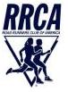
Waiver & Release
In consideration of my being admitted to enter “Sprint for the Seals”, I, for myself, my heirs, and assigns, executors and administrators, do hereby forever release and discharge Sportspectrum, RRCA, Sportspectrum Race Management, NWLRA, and all other sponsors, their employees and agents, of and from any and all claims or demands for damages, injuries, or liability, in any manner arising out of participation in this event. I agree to indemnify and hold harmless the parties released above from any claims or demands for damages, for injuries or liability, in any way arising out of my participation in this event. I certify that I have prepared myself for this race and that I am in adequate physical condition to complete the event I have entered. I agree to follow all rules of this race and to permit myself be removed from the competition if in the opinion of Race Management that continuing would endanger my health.
The “Sprint for the SEALs” Official Entry Form – “March 16, 2014”
Last Name __________________________________________ First Name ___________________________________________
Address ____________________________________________ City ___________________ Zip Code __________________
Birth Date ___/___/___ or Age____ Circle: Male or Female
T-Shirt Size (circle) YM YL S M L XL XXL (add $2.00)
I understand and agree to all conditions of waiver. Signature ______________________________________________________________________

Parent/Guardian Signature for participant under 18 years old ______________________________________________________________________

